APP.JS

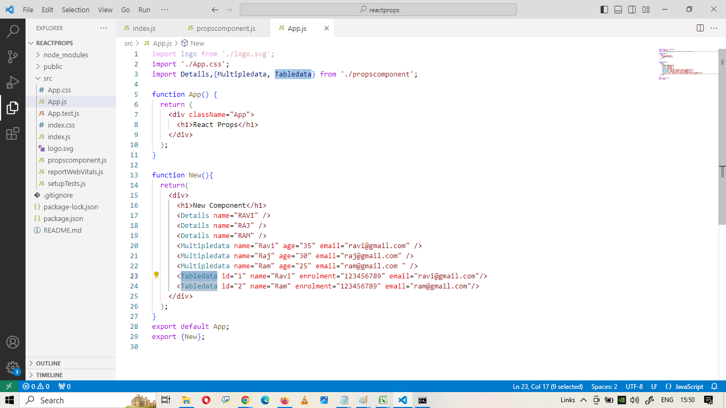

PROPSCOMPONENT.JS

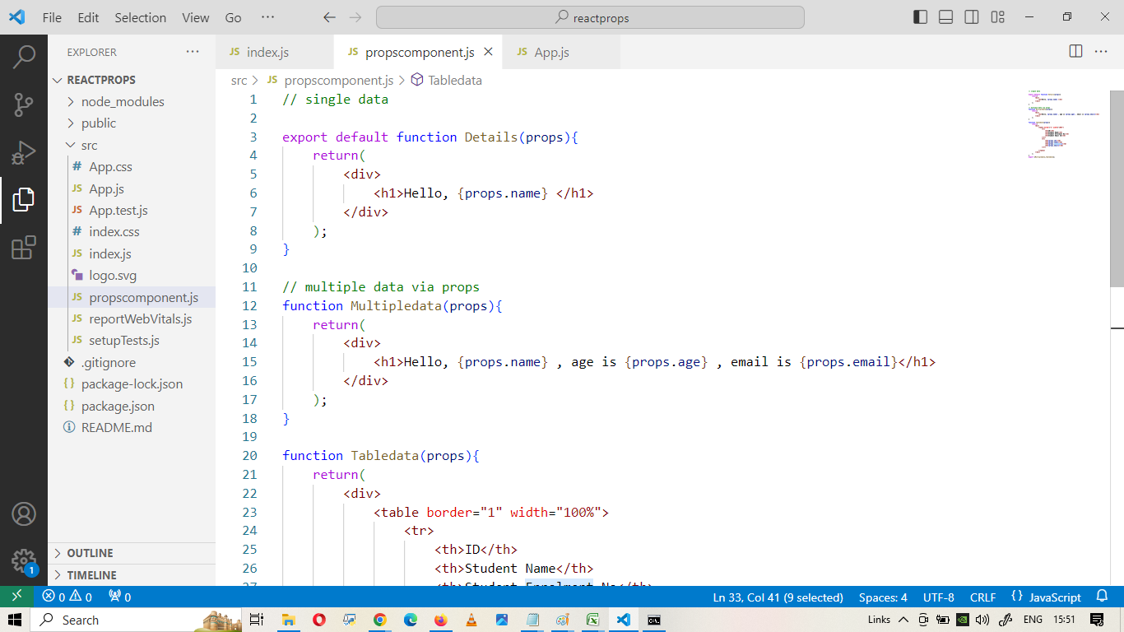

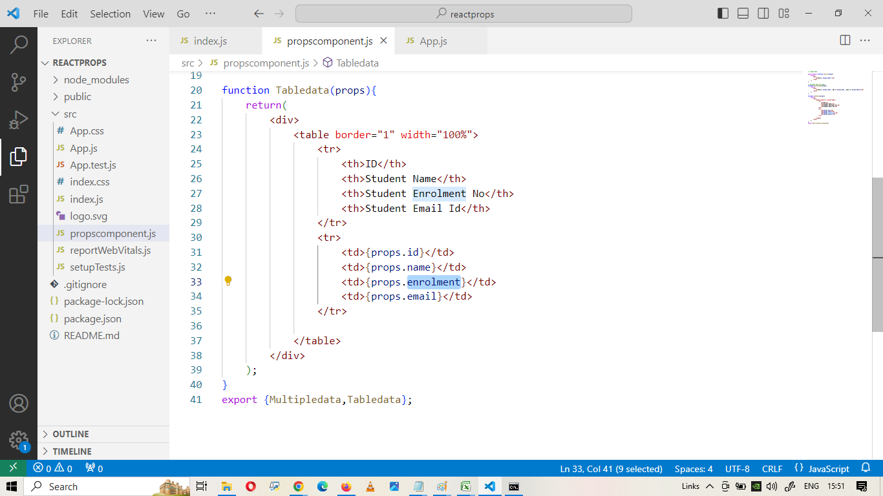

INDEX.JS

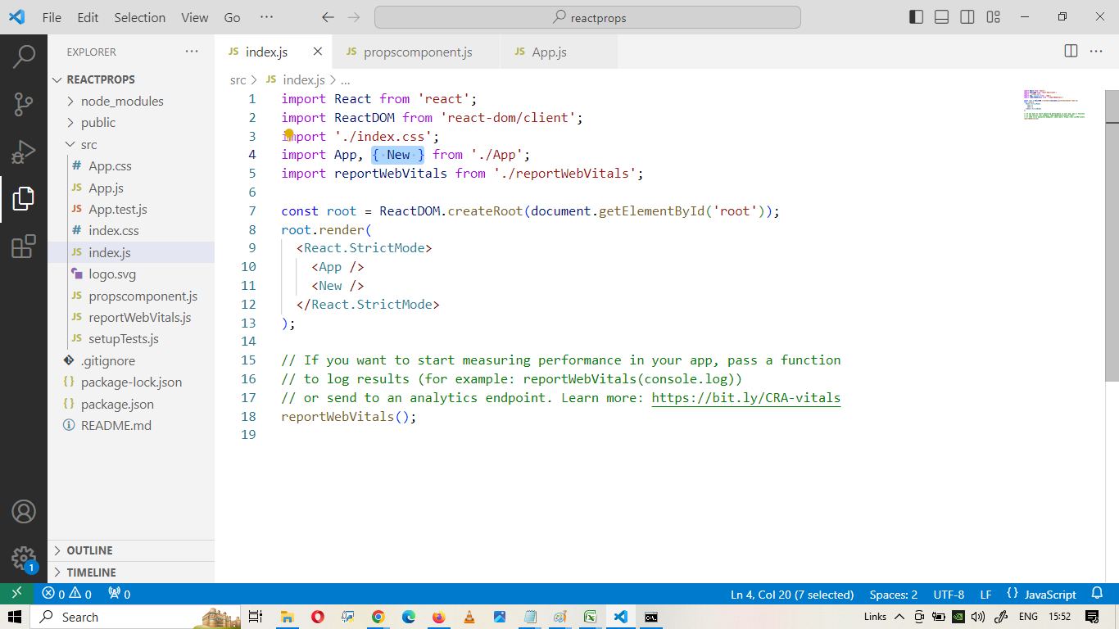

TASK 1 :

Bootstrap Table ( Striped table ) = SR NO | NAME | DESIGNATION | EXPERIENCE

Pass row data through props

TASK 2 : APPLY PROPS IN ASSIGNMENT 2 ( BOOTSTRAP CARDS )

( CREATE SINGLE CARD and Pass data through props )

